Here is the architecture of our project

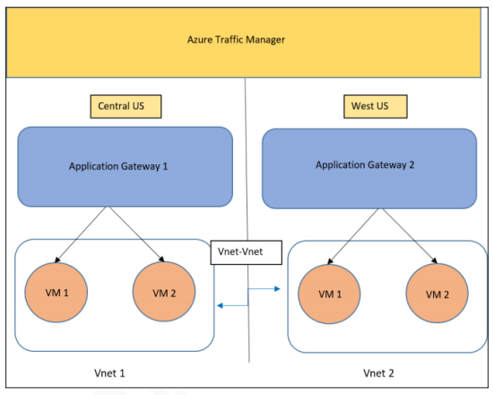

So step by step we are doing

Step 1- I have created the 4 virtual machines, in different vnet’s,

Vnet-01-> vm1 and vm2

Vnet-02-> vm3 and vm4

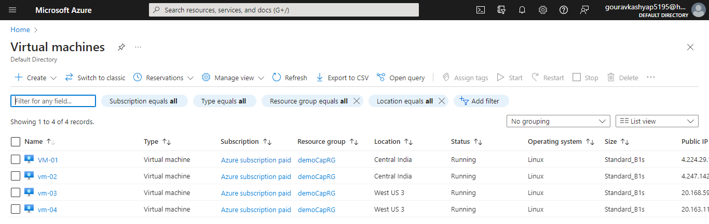

Here is my 4 virtual machines

Here I have created the two vnet i:e vnet-01(central india) and vnet-02(West US 3)

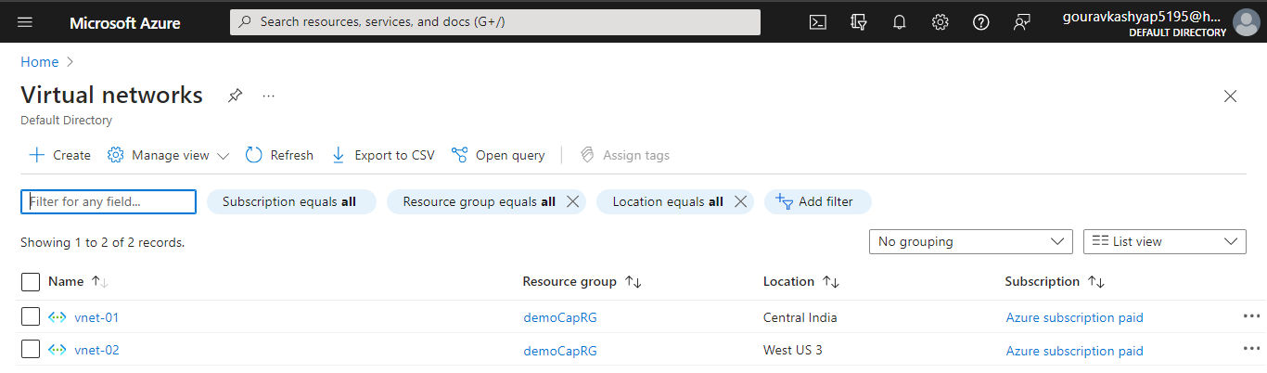

Now as our architecture we have to create two application gateways

Application gateway for “central india”

Application gateway for “west us 3”

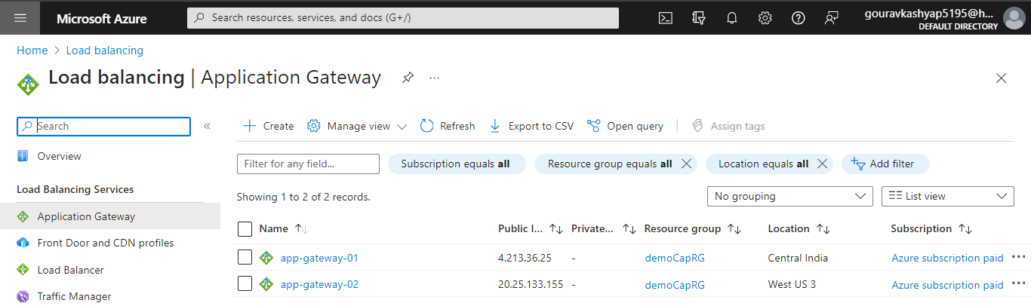

As per the instruction we have to create error.html page also that we have to upload in storage account

So first we have created the storage account

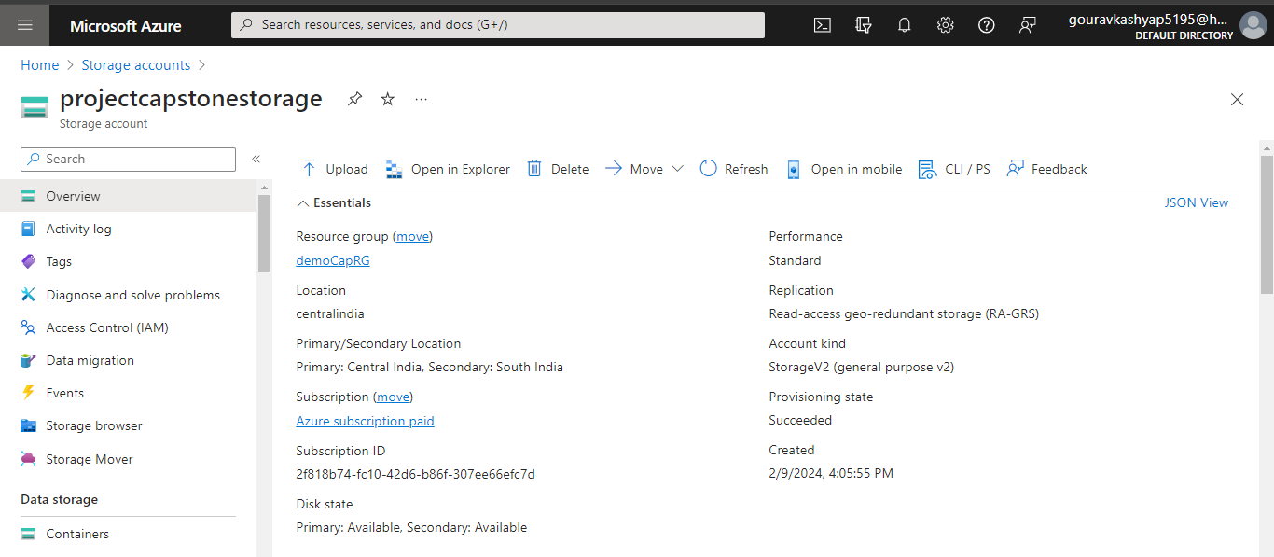

This is our storage account

Now we have upload our error.html page also

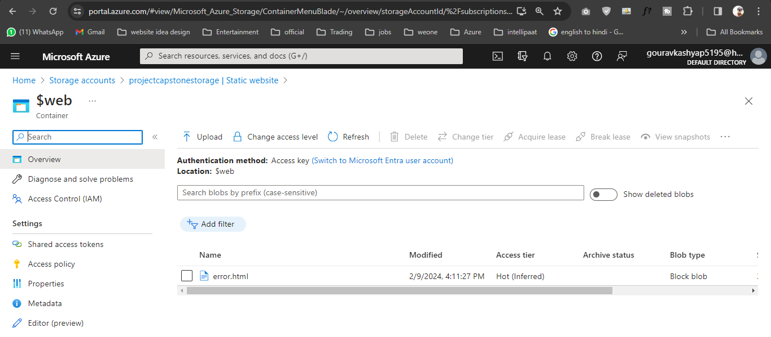

Now we have run the script on vm-02, with github code and clone it

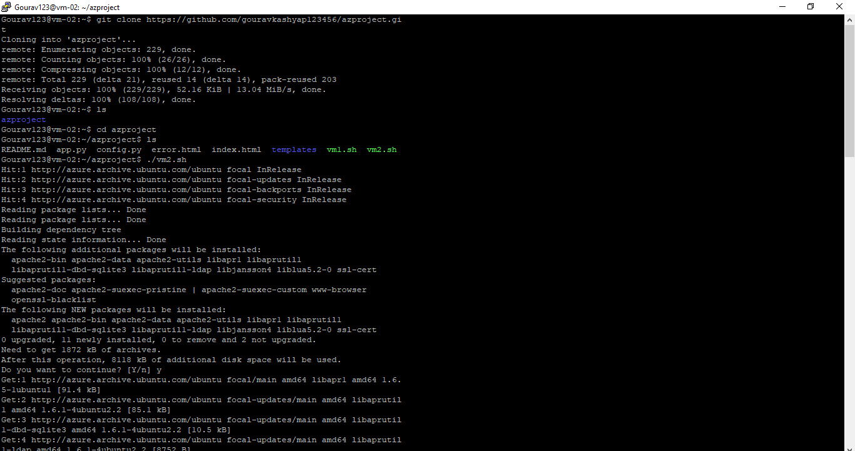

we have run the script on vm-04, with github code and clone it

we have done this for all 4 VMs

now I am creating traffic manager, you can see below

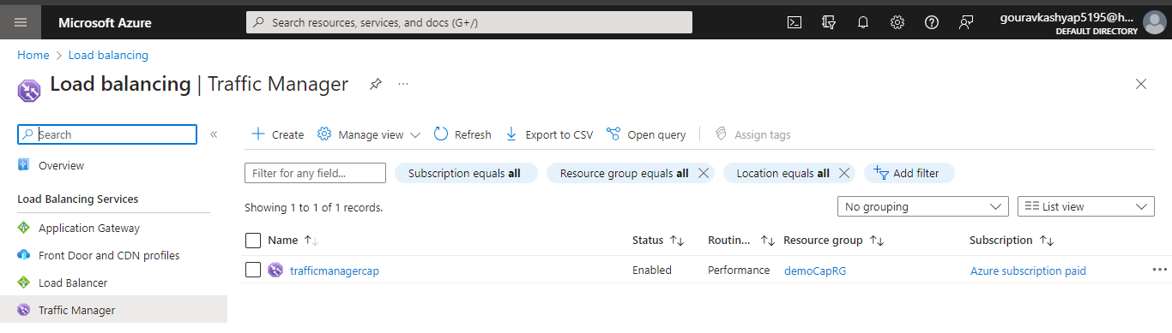

Now in traffic manager, we have to create the endpoint also

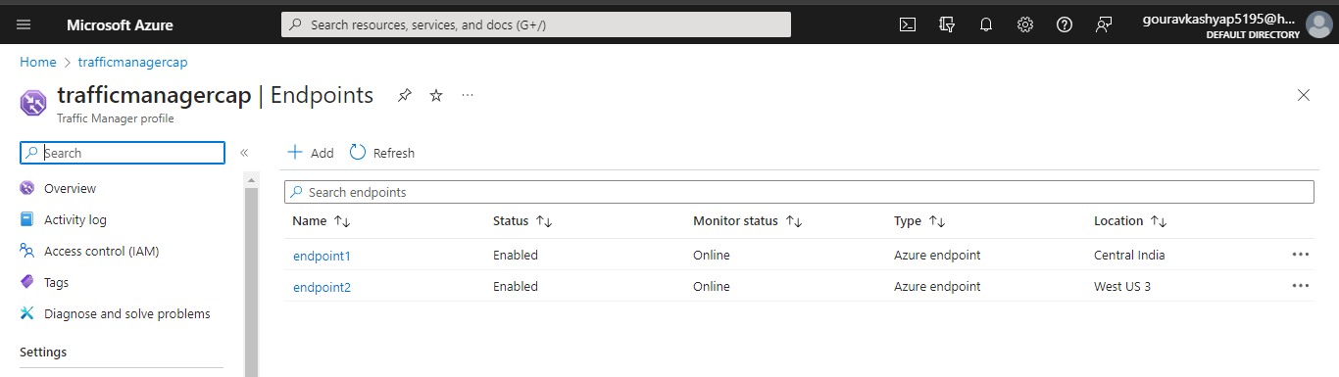

Now every thing is done now,

Here we have final output

